Raj Singh

Jordan McGhee

Project 2 Abstract

For this project we ill be utilizing ATMEGA328 microcontroller with a Wi-Fi module to create an Internet of Things Wi-Fi enabled LED strip. This LED strip allows each led to be individually controlled. With this we can utilize the Wi-Fi module to allow for remote configuration of the LED colors. We will use a button or control nob to allow for manual input as well. Please see our preliminary designs.

Preliminary Part list (Will be added to excel spreadsheet)

1. 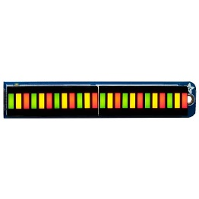LED strip 1528-2010-ND <https://www.digikey.com/en/products/detail/adafruit-industries-llc/1721/6827143>
2. 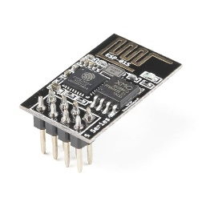WiFi Module 1568-WRL-17146-ND <https://www.digikey.com/en/products/detail/sparkfun-electronics/WRL-17146/13282842>